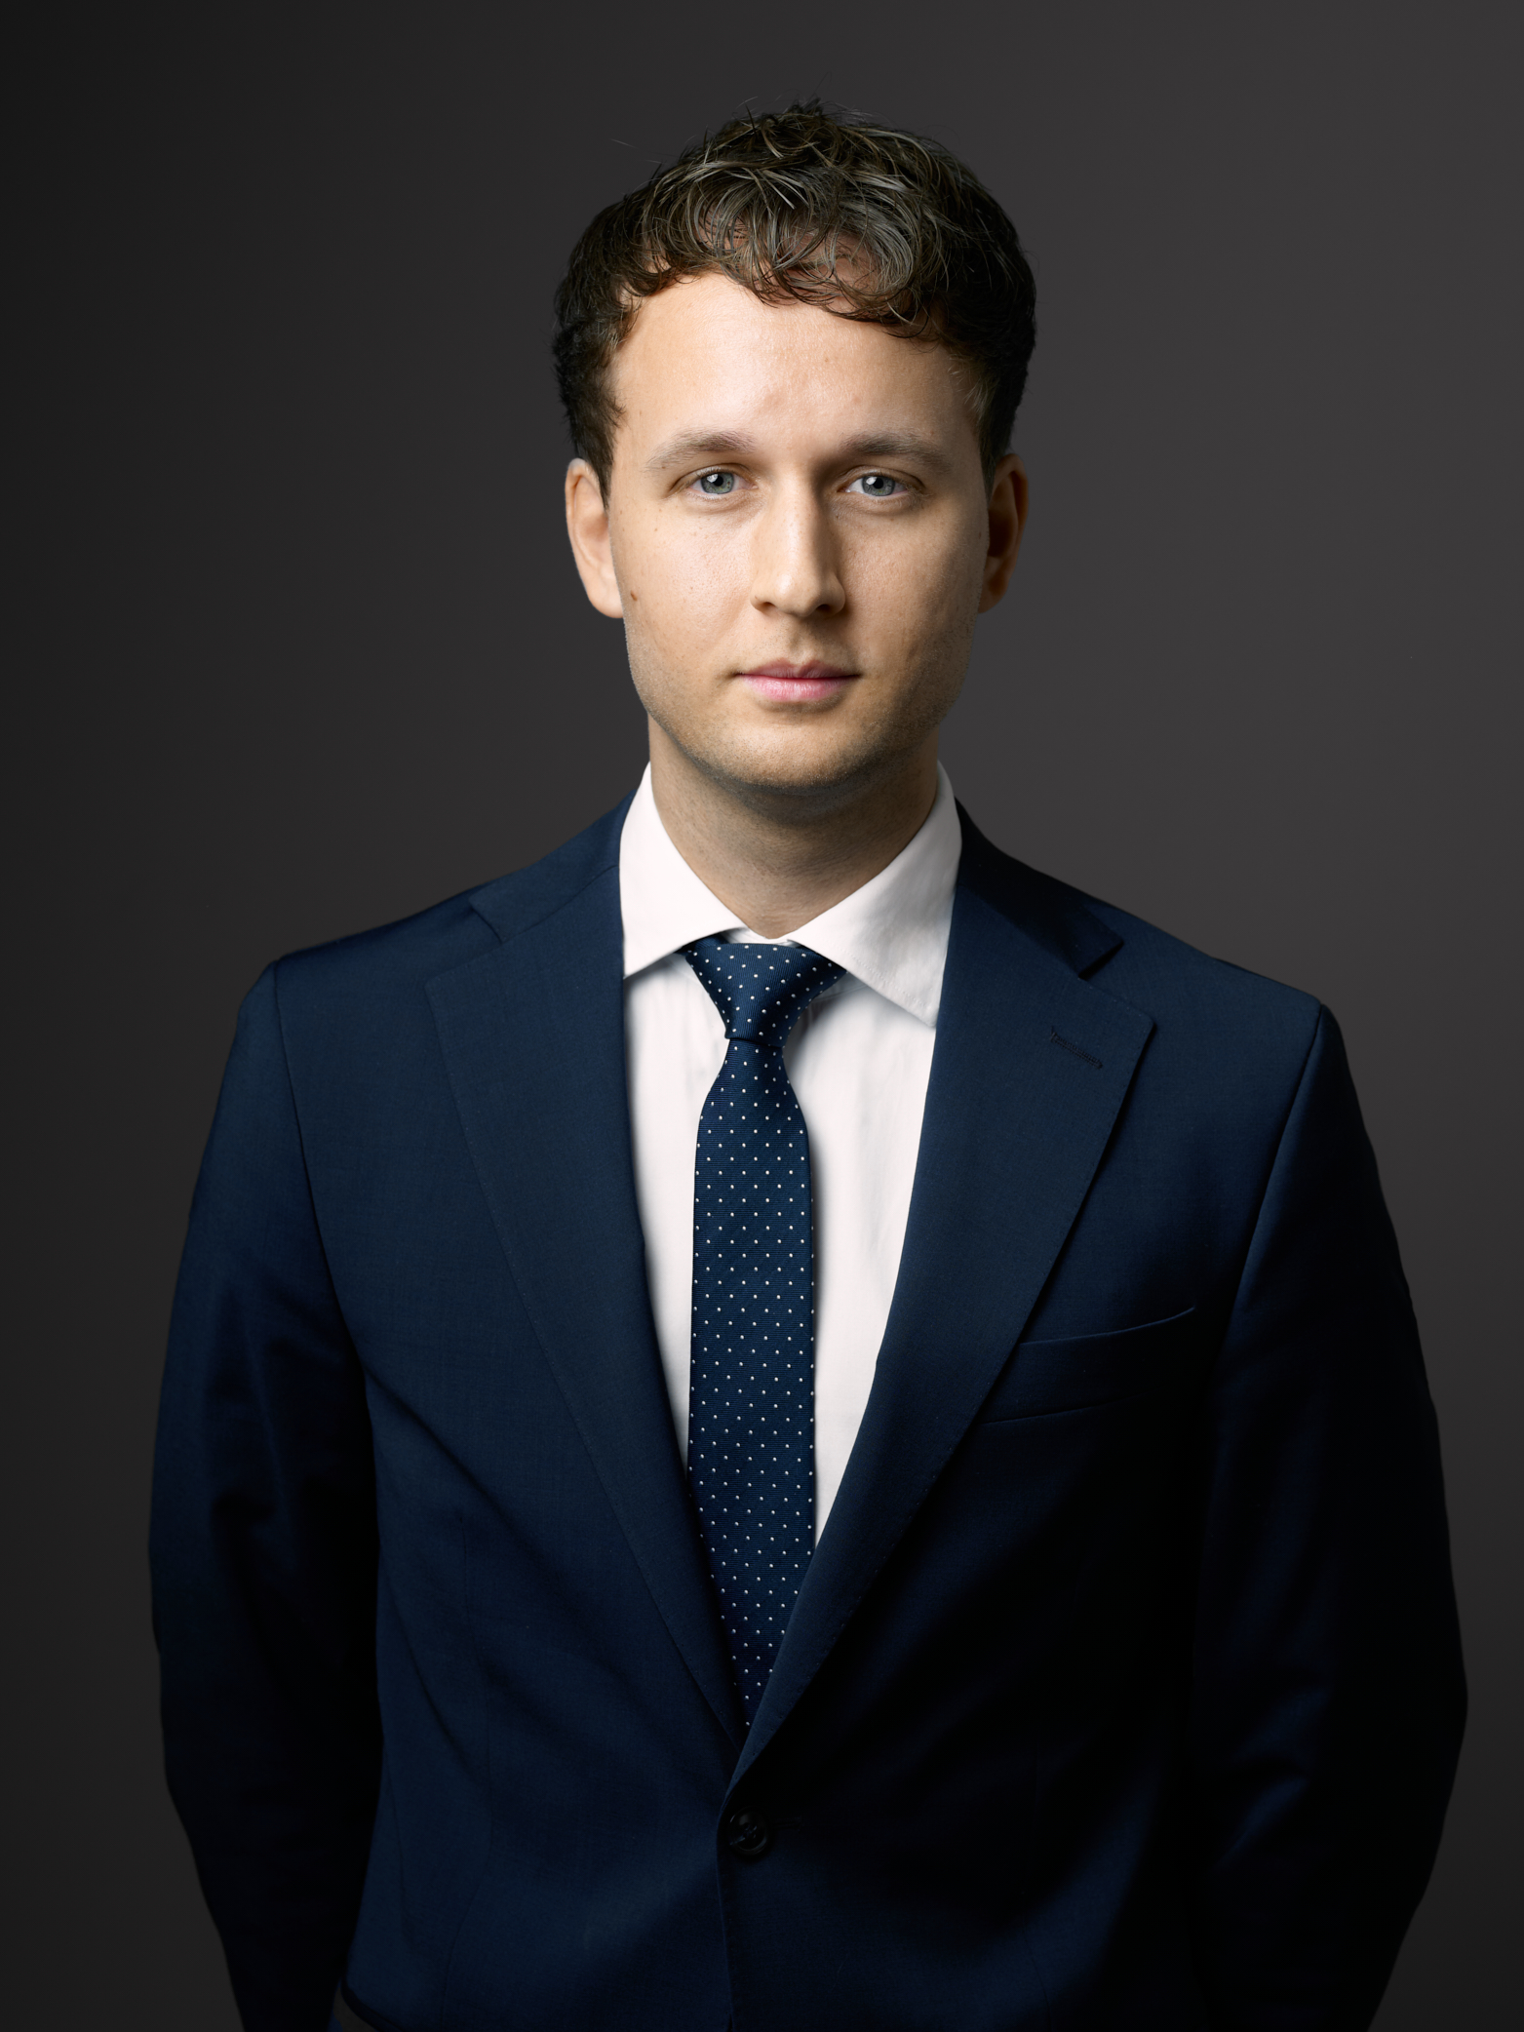 | JAKOB HAMBERT  associate  NORBURG & SCHERP ADVOKATBYRÅ AB  BIRGER JARLSGATAN 15  SE-11145 STOCKHOLM, SWEDEN  MOBILE: +46(0)84 093 32 80  JAKOB.HAMBERT@NORBURGSCHERP.SE
Jakob Hambert is an associate at Norburg & Scherp since 2024. Prior to joining Norburg & Scherp Advokatbyrå, Jakob worked as an associate at Linklaters Advokatbyrå, focusing mainly on dispute resolution. Jakob obtained his LL.M. from Uppsala University in 2022. Jakob’s working languages are Swedish and English.

Experience:
• Norburg & Scherp Advokatbyrå, Associate, 2024–
• Linklaters Advokatbyrå, Associate 2022-2024

EDUCATION:
• LL.M. 2022, Uppsala University
• B.A. in International Relations 2021, Stockholms University

LANGUAGES:
• Swedish (native)
• English (fluent)

